Goal:

1. Automatically capture purchase information on ticket marketplace websites
   1. Regularly Used Websites (full list on Asset Closedown Excel Online > Buy List Count tab):

|  |  |  |
| --- | --- | --- |
| https://www.ticketma | TicketMaster | 1855 |
| https://www.axs.com/ | AXS | 1088 |
| https://www.etix.com | Etix | 556 |
| https://concerts.liv | Ticketmaster | 191 |
| https://event.etix.c | Etix2 | 159 |
| https://seatgeek.com | SeatGeek | 116 |
| https://www.ticketwe | Ticketweb | 85 |

* 1. Purchase Information:
     1. Quantity purchased
     2. Card used
     3. Cost
     4. Purchase Date
     5. Purchase Time
     6. Confirmation Number
     7. Seat
     8. Row
     9. Section
     10. Event Name
         1. Opponent
     11. Event Date
         1. Event Time
     12. Venue Name
     13. Delivery Method

1. Provide an option to take screenshot of purchase confirmation (listed below) if extension missed initial capture.
   1. Long-term: Each miss is logged to improve extension’s accuracy
      1. Ex: When manual option button is pressed, website / screenshot information is captured and relayed to algorithm
2. Long-term: Extension tracks total daily screenshots and tickets purchased in toolbar

Confirmation Screenshot Example:

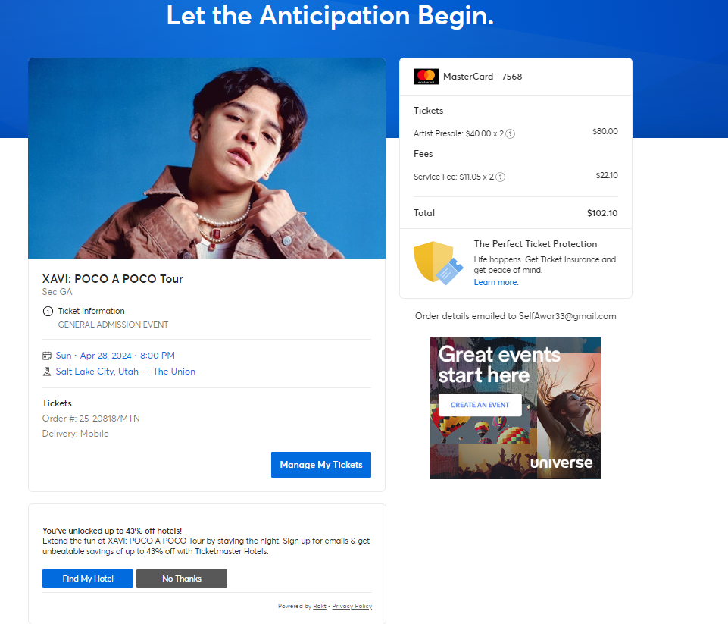

**Purchase Recordings:**

1. [Nicholas Pusateri: ETIX](https://teams.microsoft.com/l/message/19:5fc344c9-0266-4dba-865c-0970e9c5326b_d8d3a1c5-5a35-4a53-bbda-89a2038acb07@unq.gbl.spaces/1711985289669?context=%7B%22contextType%22%3A%22chat%22%7D)
2. [Nicholas Pusateri: AXS](https://teams.microsoft.com/l/message/19:5fc344c9-0266-4dba-865c-0970e9c5326b_d8d3a1c5-5a35-4a53-bbda-89a2038acb07@unq.gbl.spaces/1711984678995?context=%7B%22contextType%22%3A%22chat%22%7D)
3. <https://ticketboat-my.sharepoint.com/:v:/p/npusateri/EWD7dt23jmROpjDEmtvQGzUBKBt8LRRilS_RIYivoefSrg?e=n91Bfp> Ticketmaster
4. <https://ticketboat-my.sharepoint.com/:v:/p/npusateri/Edj1zkFtu75AhlS5KGg31FoB7Iz7SoR8x3JFBMwrE57GlQ?e=OkRHFN> Evenue